DQA on Tomo

# Purpose

This procedure details the steps involved in performing delivery quality assurance on a Tomo plan created in Tomo Planning Station.

For DQA troubleshooting tips, see “DQA Troubleshooting.”

# Steps

1. Prep the DQA plan.
   1. On one of the Tomo computers, open the plan in DQA Station.
      1. Click the Patient Selector.
      2. Locate the patient in the list, and click the arrow next to the patient’s name.
      3. Highlight the desired plan. Ensure that its status is Approved. If it is not approved, you will not be able to create a DQA plan.

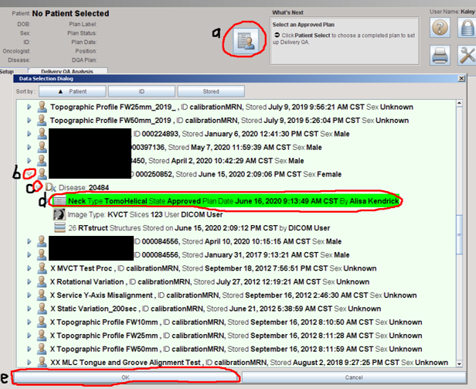

* 1. Select the Delta4 phantom.
     1. Click the Phantom Selector icon.

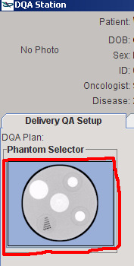

* + 1. Highlight the Delta4_2mm phantom and click *Select*.

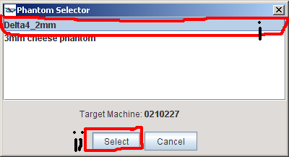

* + 1. Highlight the Delta4 phantom and click *Select*.

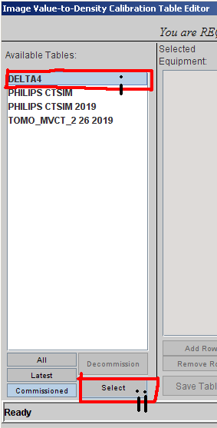

* + 1. Click *Apply to Plan*.

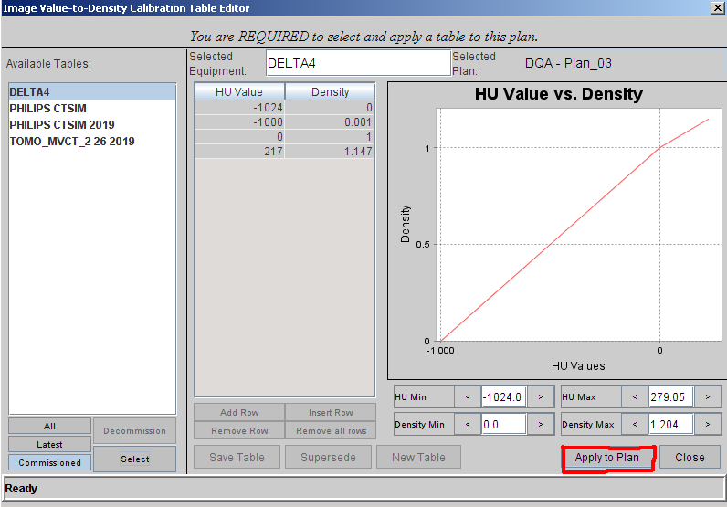

* + 1. Click *Close*.

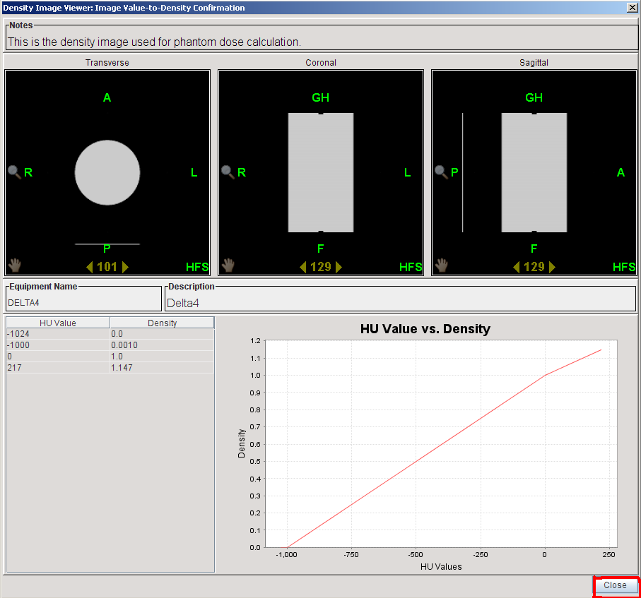

* 1. Rename the DQA plan from *Plan_01* to *<plan name> DQA*. If this name will not fit, remove letters from the end of the plan name until it does.

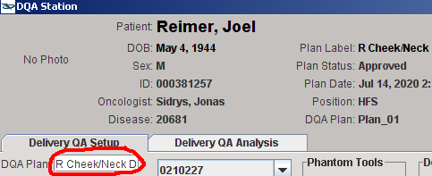

* 1. Specify view settings.
     1. Switch the Displayed Image to *Phantom*.

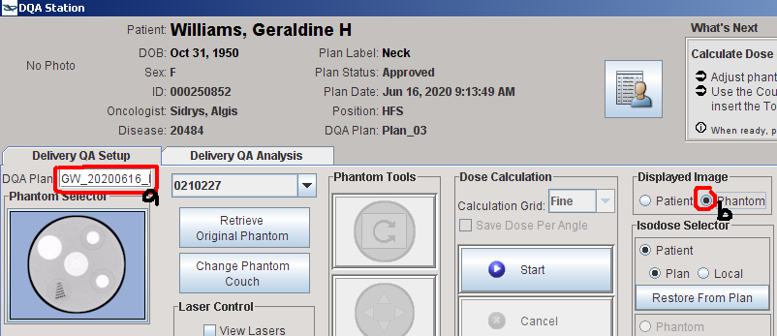

* + 1. Right-click in the scrollbar on any of the images and select *Low Density*.
    2. In each plane, scroll until you can see BBs.

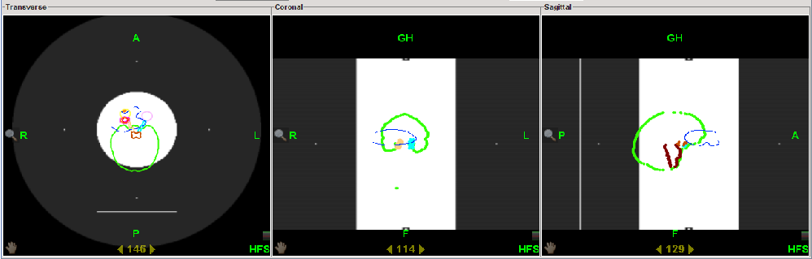

* 1. Turn off display of all structure contours.

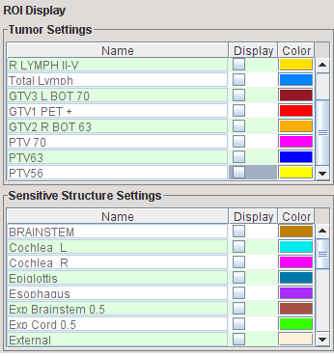

* 1. If tumor is not approximately centered on phantom, move phantom.
     1. Click *Move Phantom*.

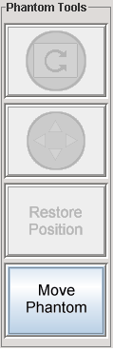

* + 1. Click the arrows button (*Move Phantom Position*).

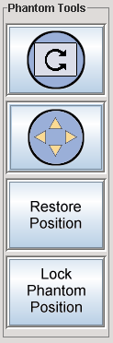

* + 1. Click and drag to move phantom in each view so that BBs align with tumor.

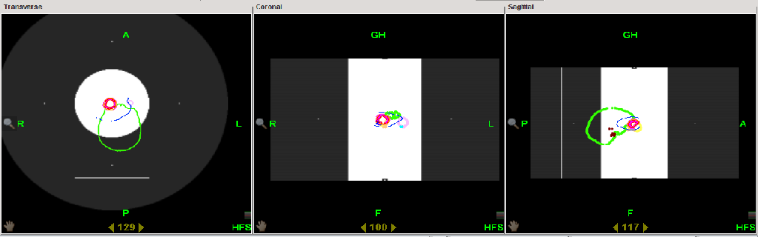

* + 1. Click *Lock Phantom Position*.

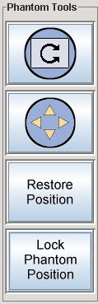

* 1. OPTIONAL: Set TCS views.
     1. Right-click in any of the views and check *Gang TCS Views*.

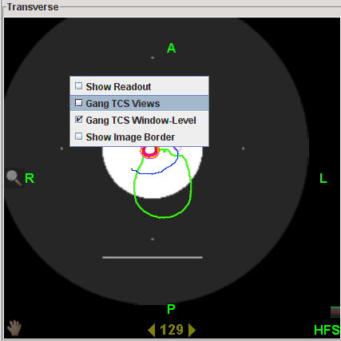

* + 1. Scroll in each plane to best align the view lasers (magenta, cyan, and yellow) to the BBs.
  1. Align lasers to BBs.
     1. Check *Move Lasers*.

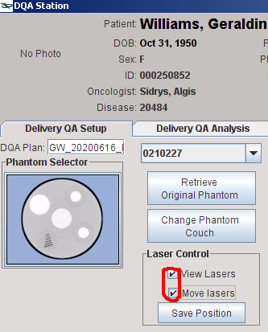

* + 1. Zoom in and align each red laser to the BBs.
    2. Save the position of the red lasers.

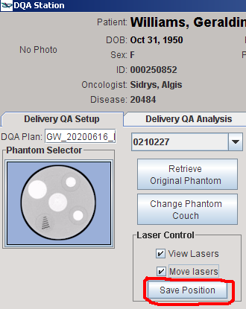

* 1. Add the couch.
     1. Click *Change Phantom Couch*.

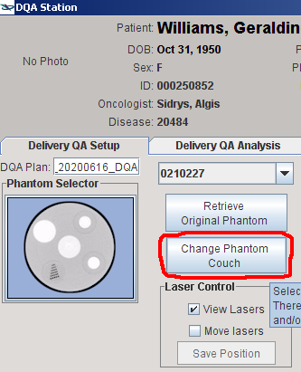

* + 1. Click the gray horizontal line below the phantom. A red line should appear. Click *Insert Couch*.

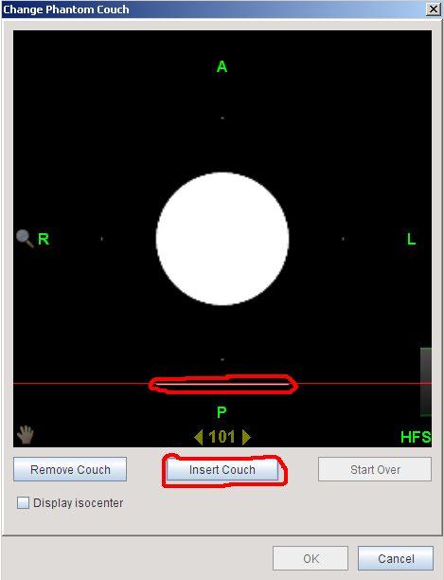

* + 1. Click *OK*.

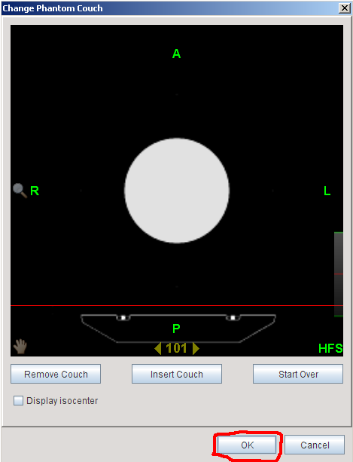

* 1. Compute the dose by clicking *Start*.

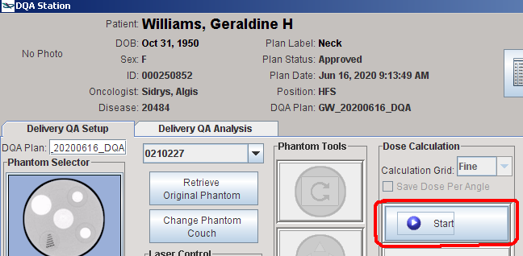

You will see the following while the job is running.

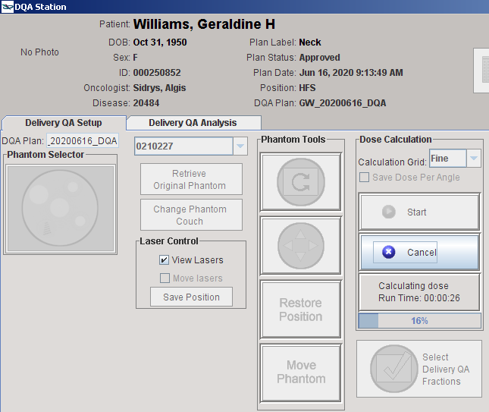

* 1. Select fractions to export.
     1. Click *Select Delivery QA Fractions*.

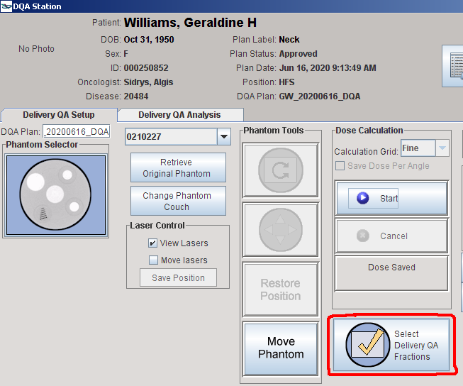

* + 1. Check the first four boxes. This gives you four fractions just in case a mistake is made or DQA needs to be shot with multiple setups.

Note the number of fractions. In the below photo, it is 39.

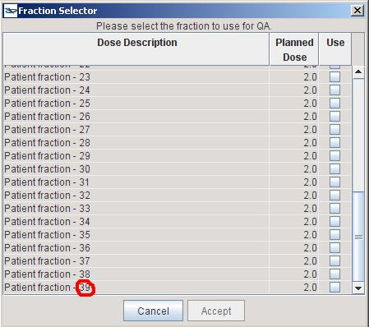

* + 1. Click *Accept*.

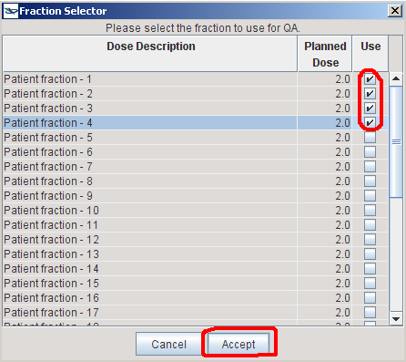

* + 1. Click *Proceed*.

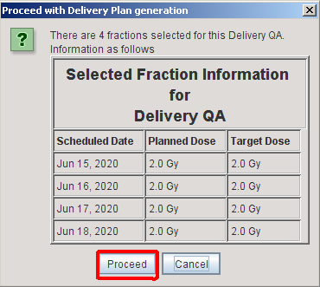

* + 1. Click *OK*.

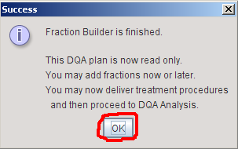

1. Ensure that the electronics in the Delta4 phantom will not be damaged. Zach’s rule of thumb is that the electronics can withstand 20 cGy per fraction.
   1. Right-click in the coronal view. Select *Show readout*.

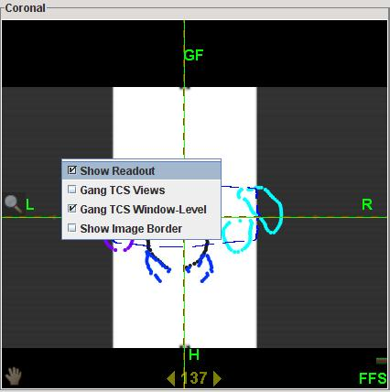

* 1. Under Isodose Selector, select the *Phantom* radio button.

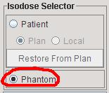

* 1. Click anywhere on the Dose Display.

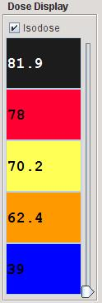

* 1. Change the first percentage to the following: 20 cGy × # of fx / reference value in cGy (7800 in the below photo) × 100.

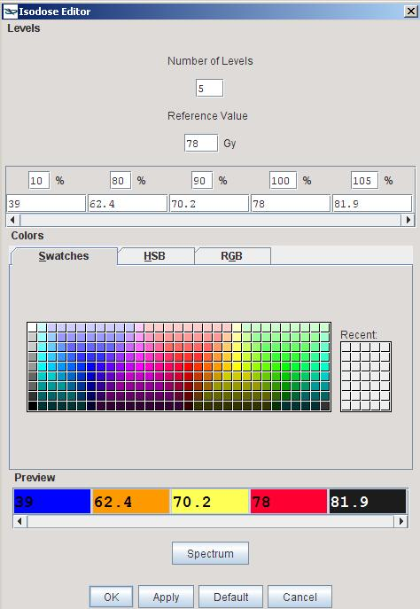

Click *OK* twice.

* 1. Place the cursor at the inferior edge of the 20 cGy line in the coronal view.

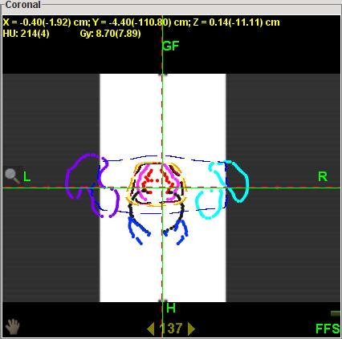

Note the Y readout. In the above photo, it is 4.4 cm. Ensure that this number is less than ~24. (The distance from the center of the Delta4 phantom to the electronics line ~22.5. On Tomo, the 22.5 line is a couple cm below the inferior edge of the phantom that is displayed in the coronal view.)

1. Export the DQA plan from Tomo.
   1. Clear the patient from DQA Station.

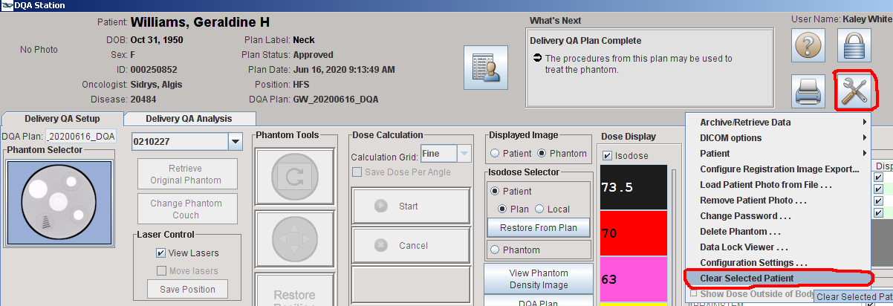

* 1. Minimize DQA Station. Open the Delta4 folder on the desktop.
  2. Double click to run the DICOMpiler.

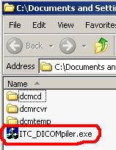

* 1. Click *OK*.

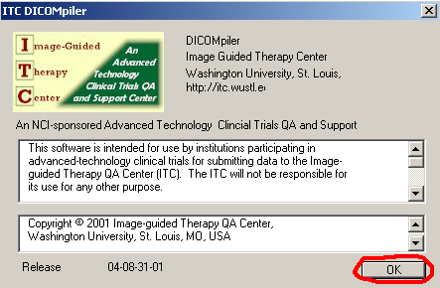

* 1. Enter the following values:
     1. Sponsor: patient last name
     2. Protocol: patient first name
     3. Case: patient MR# without the three leading zeroes
     4. Initials: your initials

Click *Make Patient ID*.

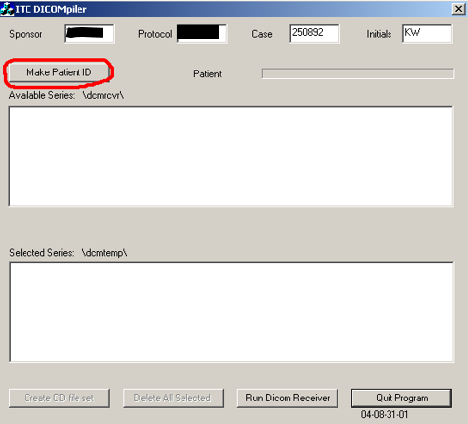

* 1. Click *Run DICOM Receiver*. The *ITC DICOM Receiver* dialog box will appear.

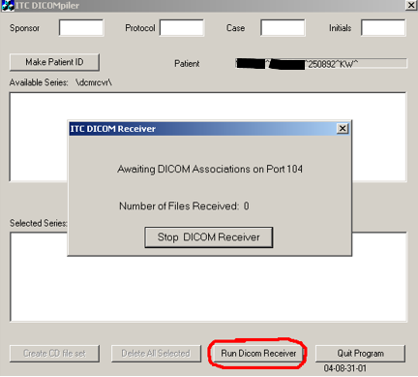

* 1. In DQA Station, go to *Toolbox* > *DICOM options* > *Export items…*

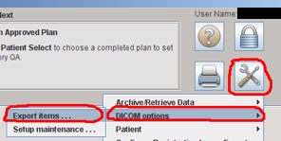

* 1. Navigate to the new DQA plan and click the arrow beside it. Ctrl+click to select the DQA plan and the Delivery_QA_Dose.

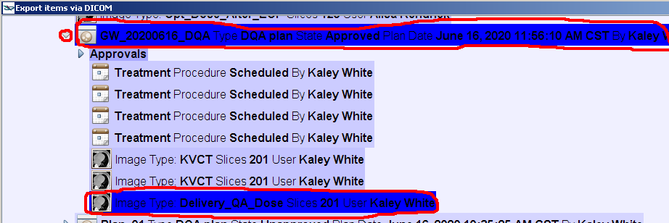

* 1. If you are on Tomo computer #1, select *Delta4_Local* from the *<Select a destination>* dropdown. If you are on Tomo computer #2, select *Delta4_PS2 Local*.

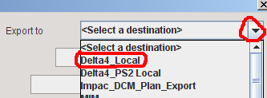

* 1. Click *Send Now*.

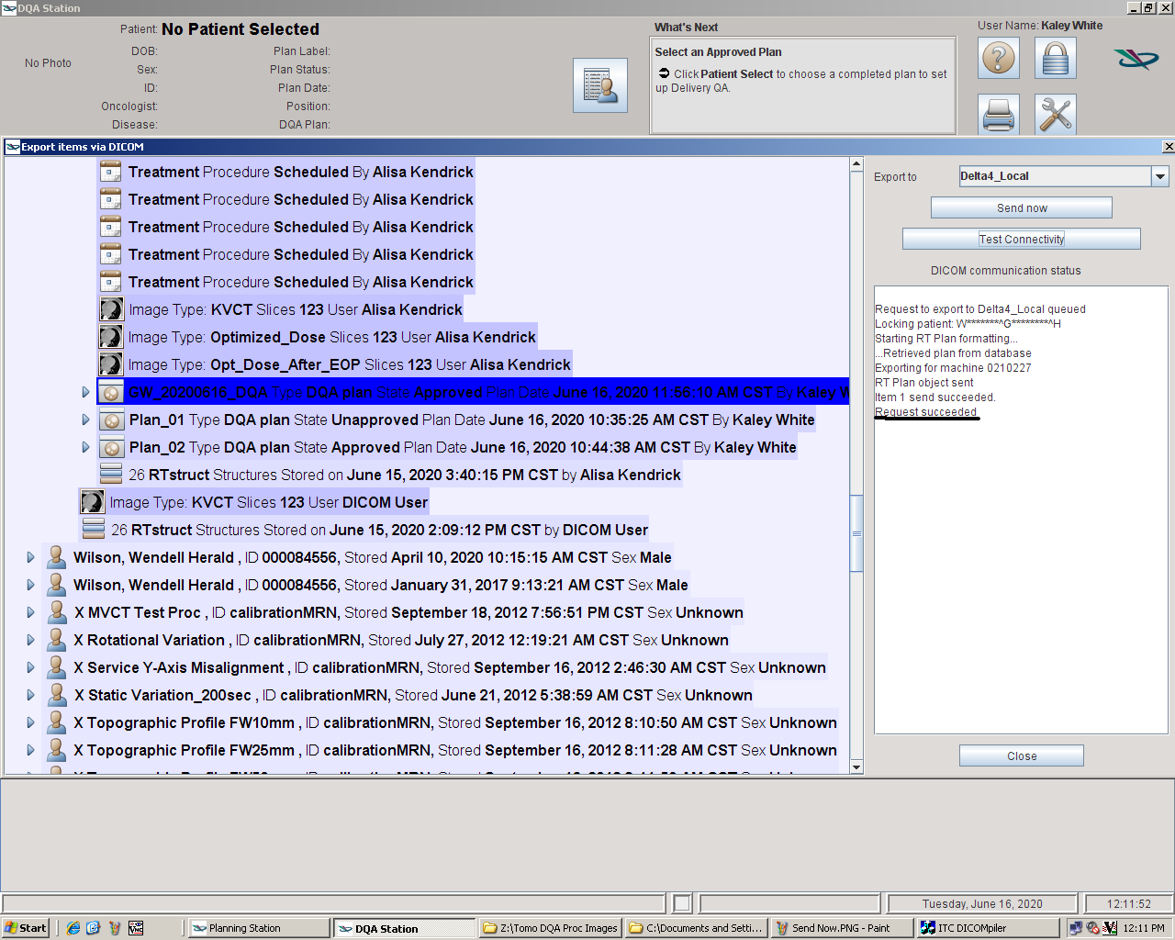

* 1. If both the DQA plan and the delivery dose were exported successfully, you will see *Request Succeeded*.

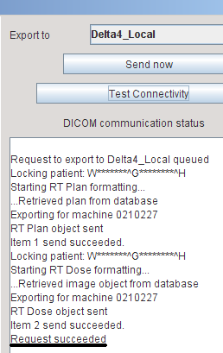

* 1. The DICOM receiver should have received two files. Stop the DICOM receiver.

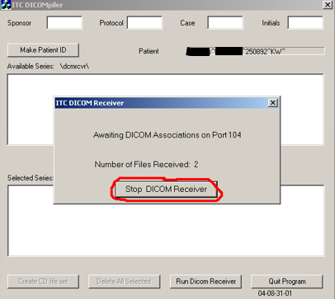

* 1. Move all files to the *dcmtemp* folder by clicking *Select All Series*.

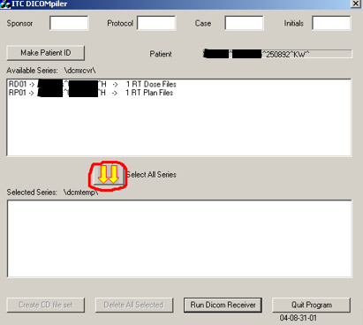

* 1. Move the files from dcmtemp to the T: drive.
     1. Create a new folder in **Z:\TreatmentPlans** with the same name as the DQA plan (i.e., *<last name>, <first name> <plan name> DQA*).



* + 1. Copy all files from dcmtemp to the new folder on the Z: drive called *<last name>, <first name> <plan name> DQA*.

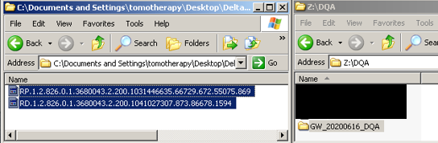

* 1. Delete all files from dcmtemp and close the DICOMpiler.

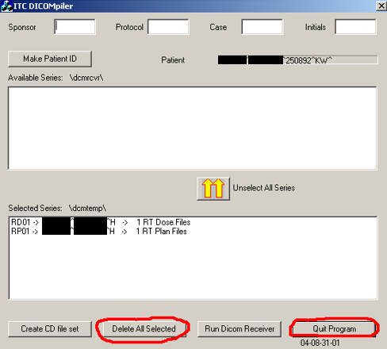

1. On another computer, move the new folder from the Z: drive to **T:\Physics\QA & Procedures\Delta4\DQA Plans**.
2. Set up the Delta4 computer.
   1. Ensure that Tomo is free at the time that you want to shoot QA. You can check RO Treatment in MOSAIQ.
   2. Unplug the network and power cables from the Delta4 computer. Take the Delta4 computer to the Tomo console. Plug in the network cable from behind the printer and the phantom cable from behind the computer in the corner.
3. Open the DQA plan on the Tomo computer.
   1. If THERAPIST is logged in, log out.

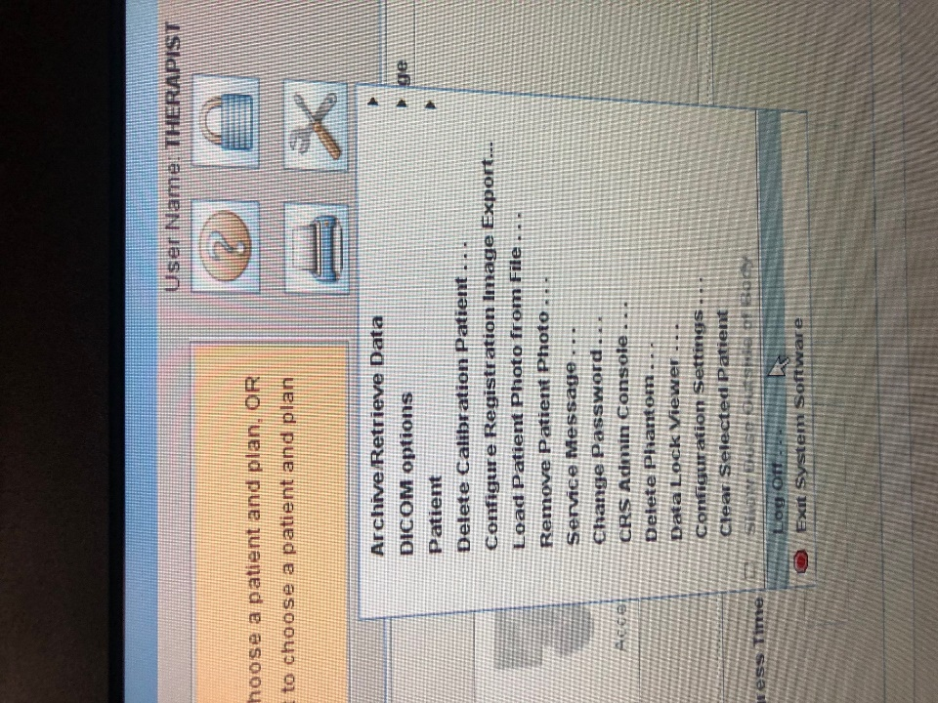

* 1. Log in using your username and password. Note that you must have Physicist rights to perform DQA.

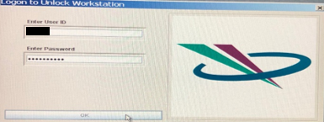

* 1. Click the Patient Selector. Navigate to and highlight the DQA plan you created in step (1). Click *OK*.

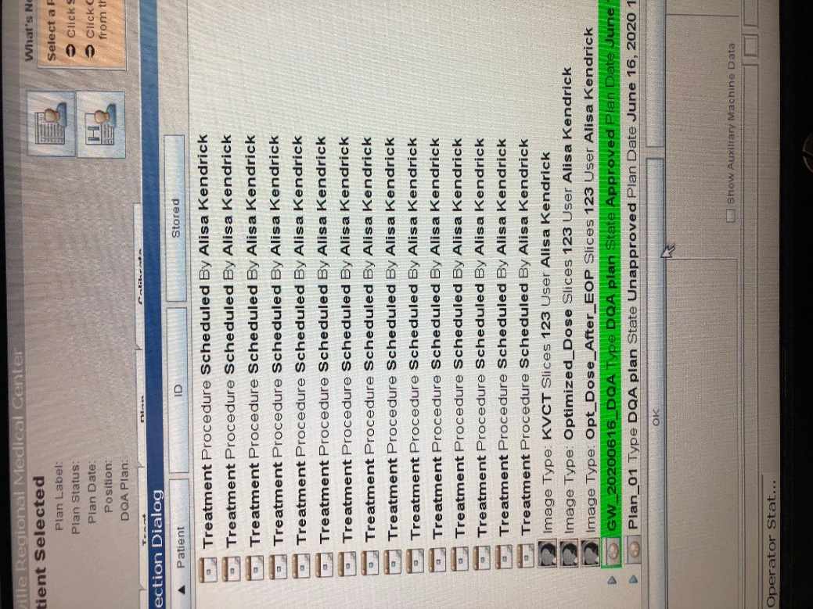

* 1. Click *Yes*.

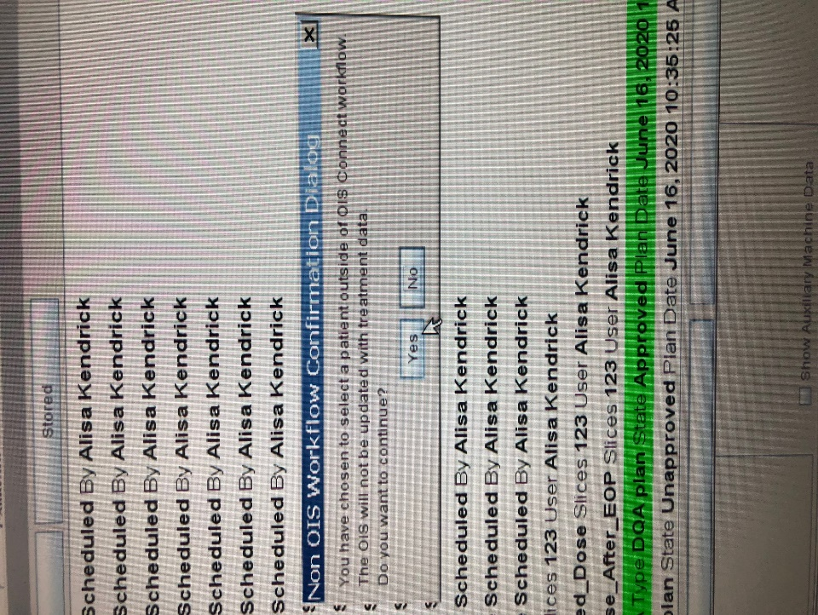

1. Prepare to shoot DQA.
   1. Navigate to the *Treat* tab.
   2. Select a DQA fraction.
   3. Click *Prepare treatment*.
   4. Click *Yes*.



* 1. Click *OK*.

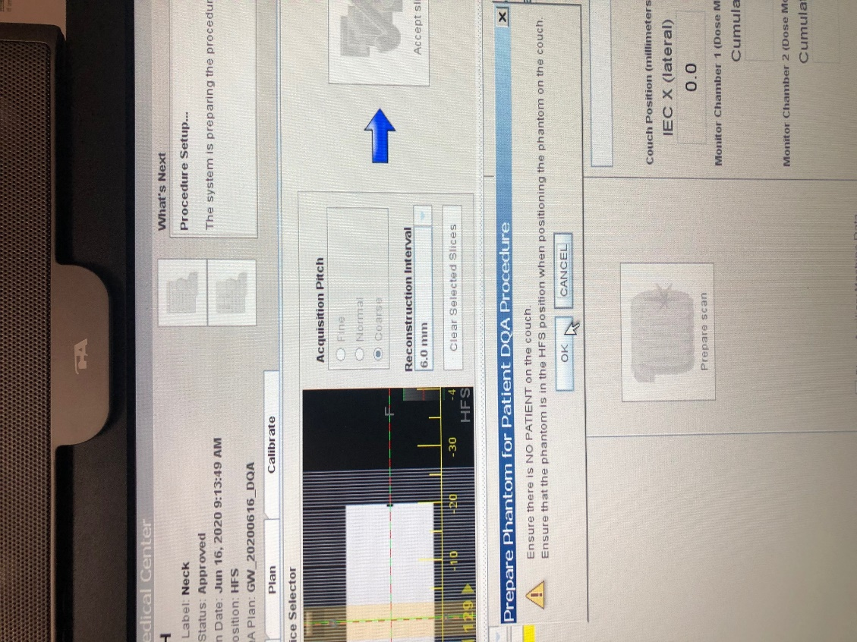

1. Set up the Delta4 phantom.
   1. Get the Delta4 phantom cart from the hot lab. The hot lab key is in the cabinet to the top right of Kaley’s workstation. Unplug the phantom. Get the yellow thermometer from the hot lab (OPTIONAL). Push the cart into the Tomo treatment room.
   2. If the therapists have anything on the table, scoot it to the end of the table.
   3. Push the phantom cart toward the table, and use the controls to raise the table so that the lip of the cart just overlaps the table. While holding down the large button on the bottom of the controls, push the Z switch up.
   4. Gently push the phantom onto the table, exerting some vertical force.
   5. Plug the phantom into a wall outlet if it doesn’t have enough power to run DQA. You may need the extension cord that is in the emesis bin on the cart.
   6. Turn on the phantom. The Wi-Fi light should blink blue.

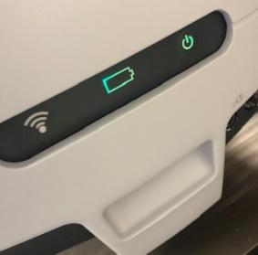

* 1. Align the phantom with the lasers.

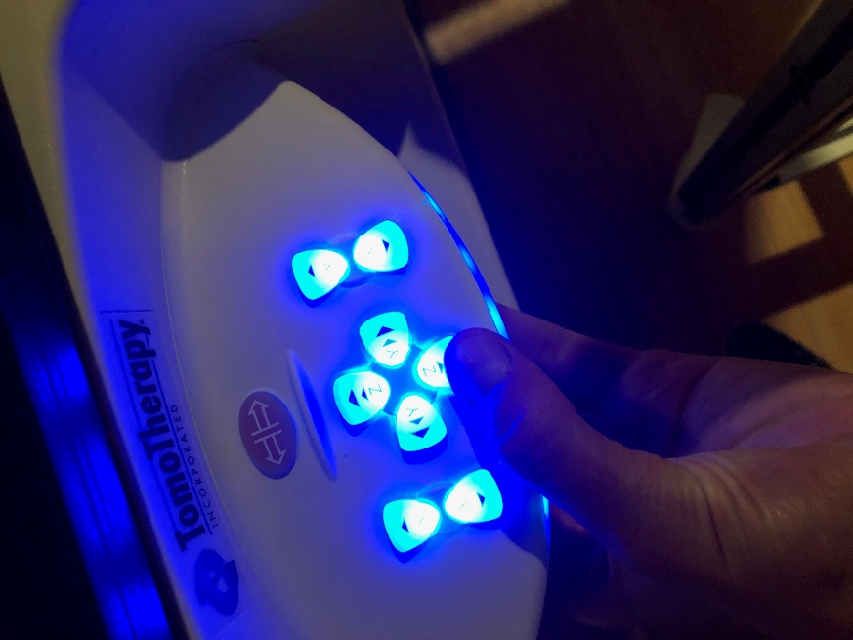

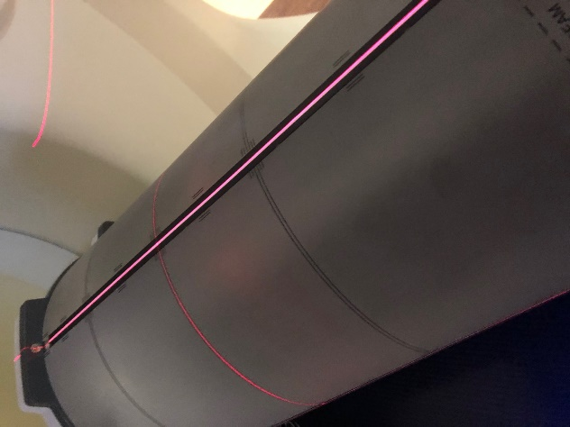

1. OPTIONAL: Use the yellow thermometer on the phantom cart to take the temperature on top of the phantom. Wait a couple of minutes for the temperature to stabilize.
2. Prepare the Tomo computer to shoot the field.
   1. Press the yellow *Stop* button on the Tomo console.

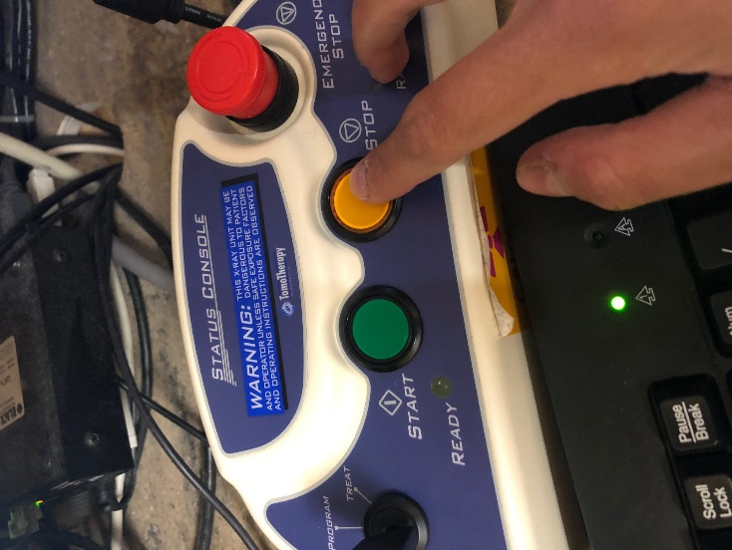

* 1. Wait until the System Interruption dialog box appears. Enter your password and click *OK*.

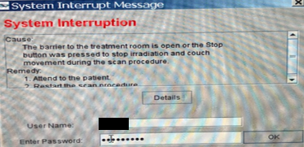

* 1. Click *OK*.

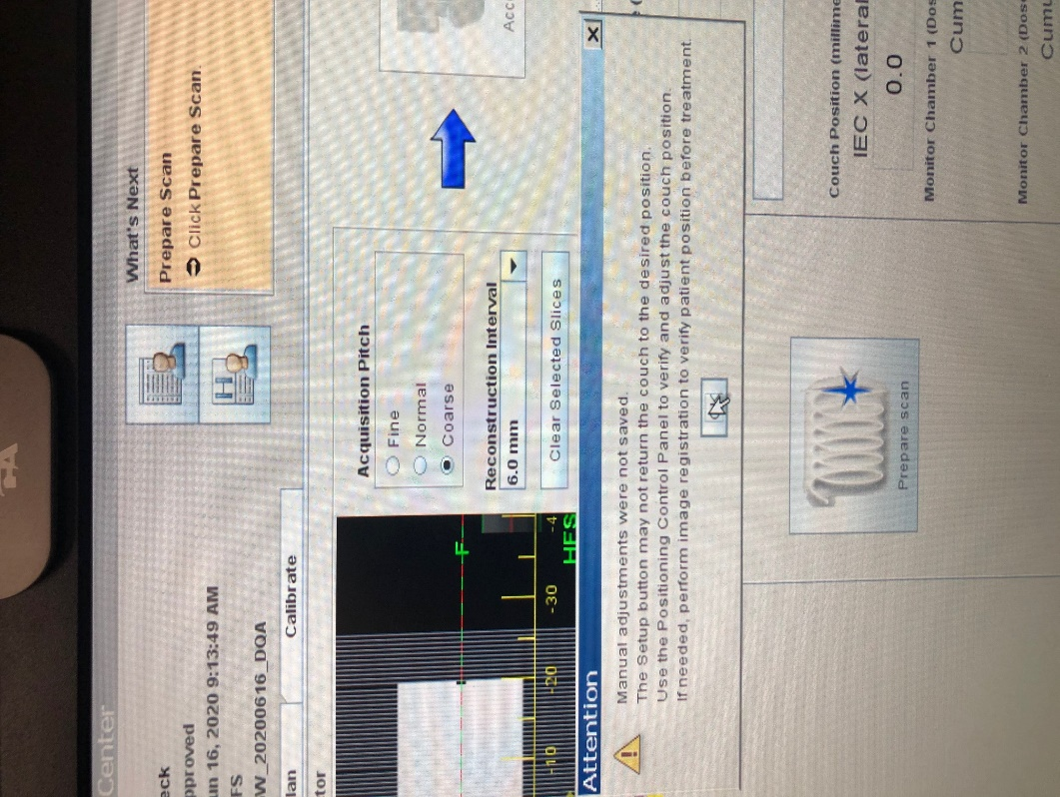

* 1. Go to the Treat tab. Select one of the DQA-TRMT fields and click *Prepare Scan*.

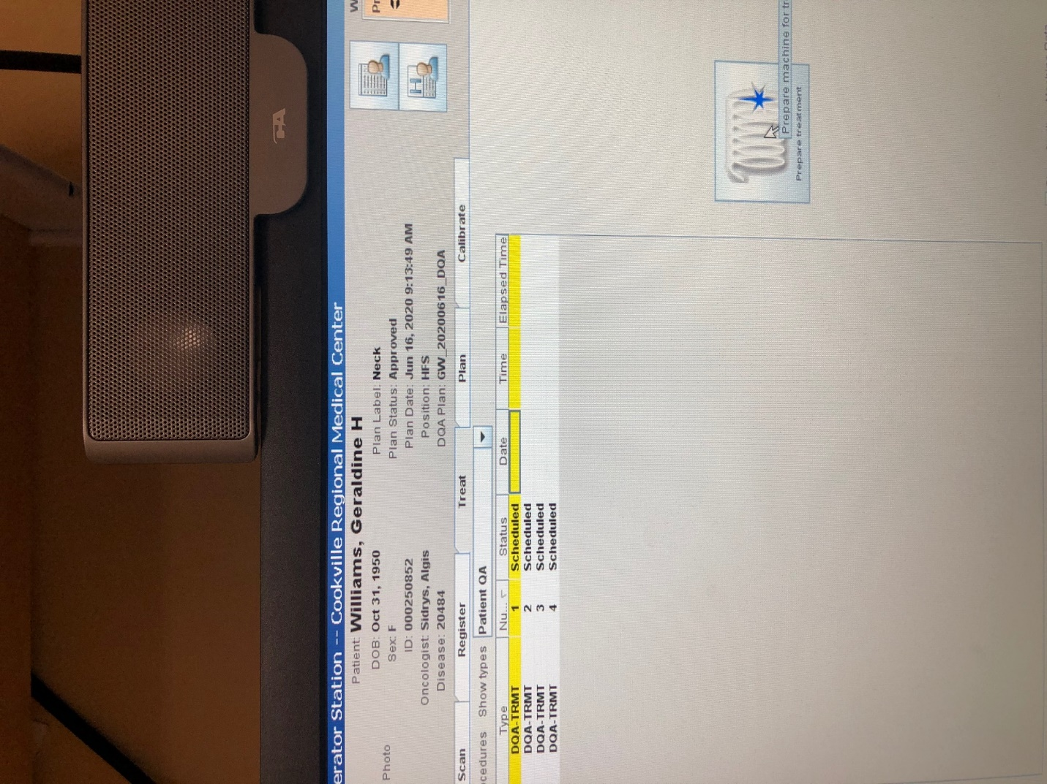

* 1. Click *Yes*.



* 1. Click *Ready*.

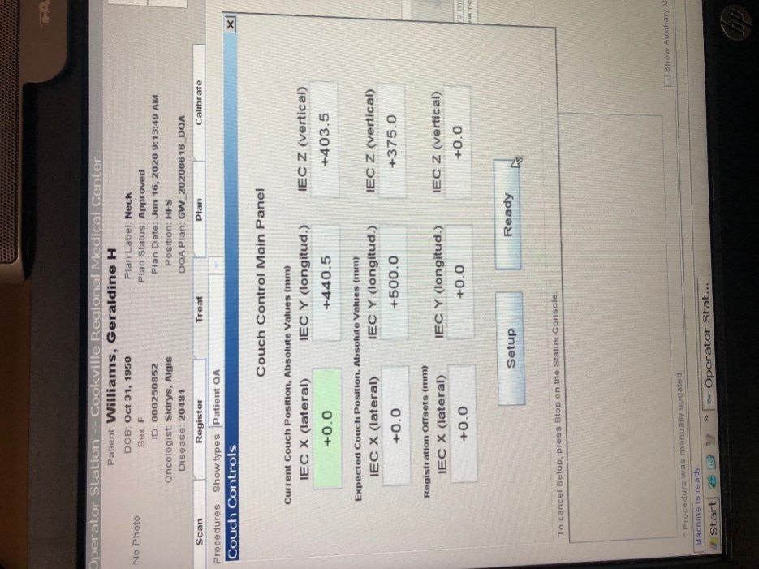

* 1. Click *Yes*.

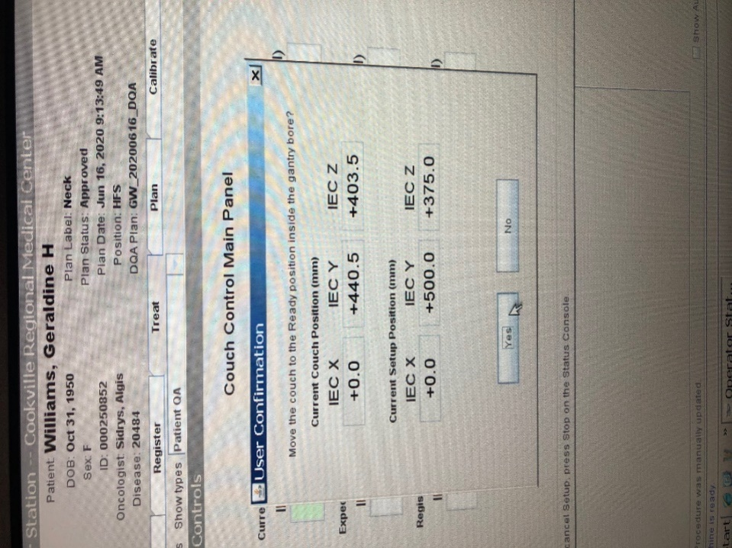

* 1. Click *Continue*.

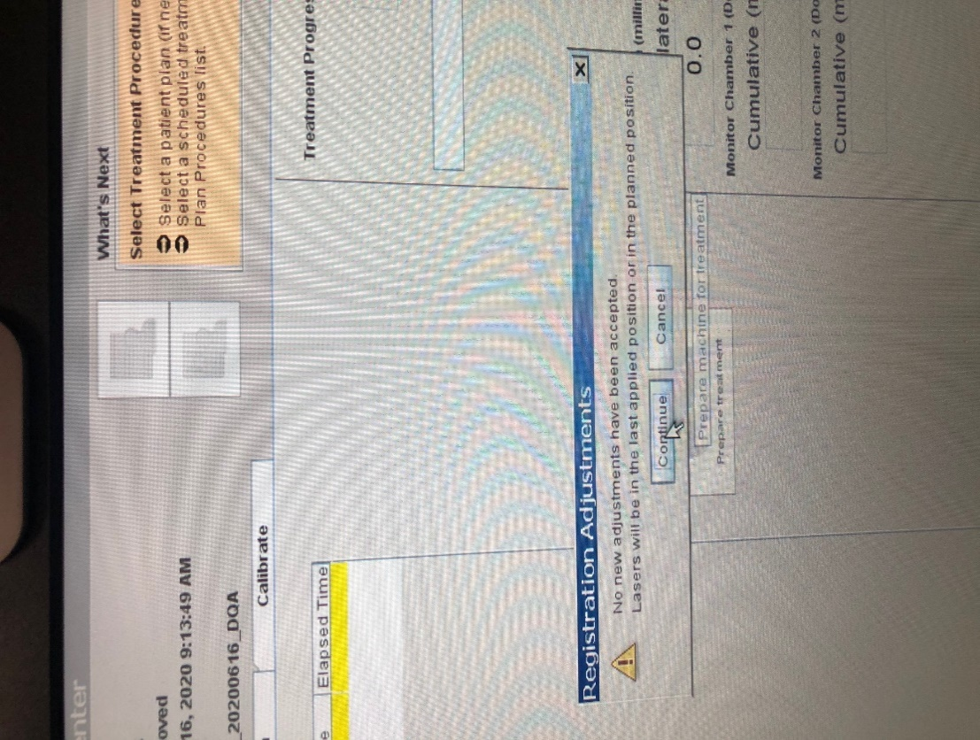

* 1. Click *OK*.



Wait until the following message appears:

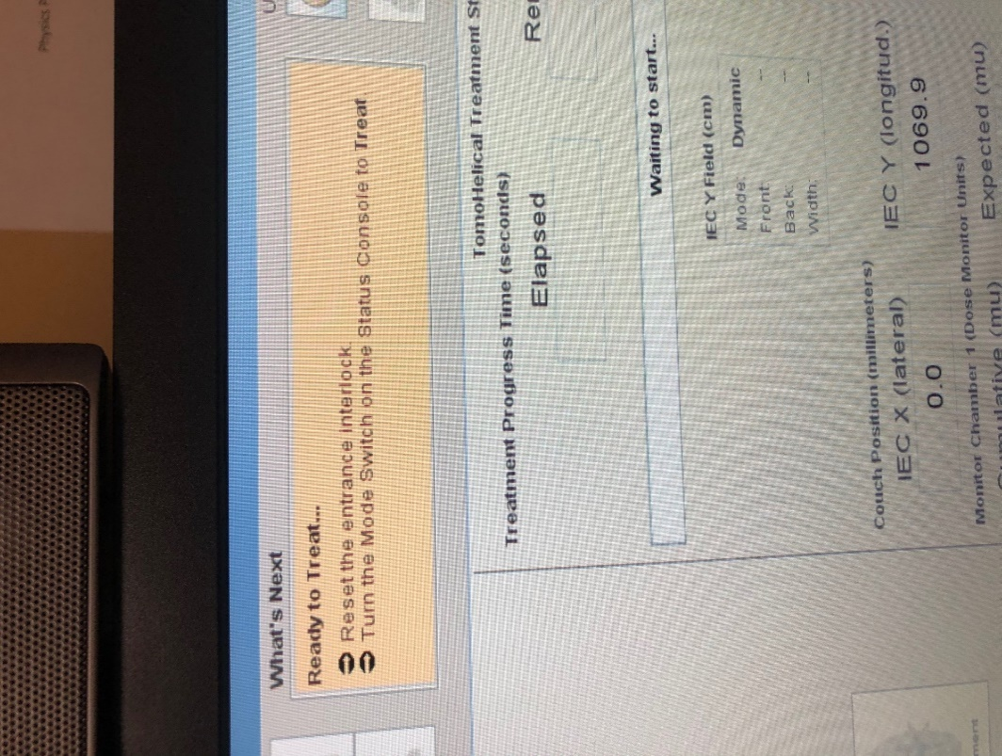

1. Shoot each field. See section “Collecting Dose” in procedure “Delta4 for DQA.” Some Tomo-specific instructions:
   1. When Delta4 says “Waiting for radiation…,” turn the key on the Tomo console to *Treat*. When the *Ready* light turns green, press the green *Start* button.

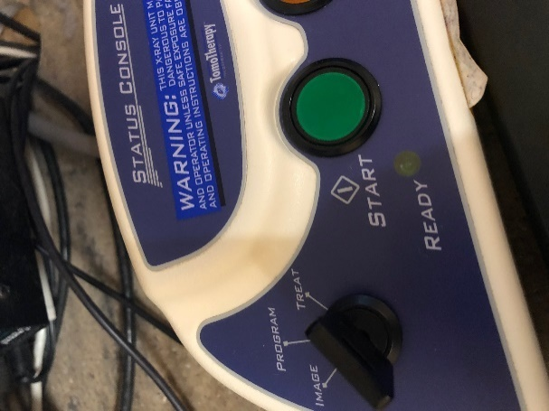

It will take a few seconds for the beam to come on. When it does, you will hear a beep.

* 1. When the progress bar finishes, turn the key on the Tomo console to *Program*.

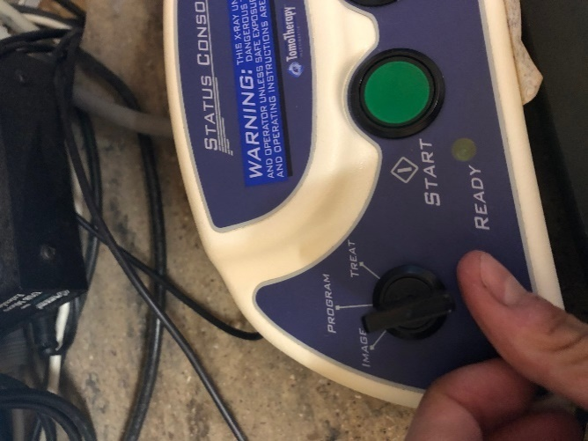

1. Unload the Delta4 phantom from the table. Turn off the phantom. Restore the table setup to the way it was before you shot QA, including unloading the couch.
2. Log out of the Tomo software. Log back in as a therapist using username *therapist* and password *therapist1*.
3. Optionally, leave a Post-It note on the monitor saying what time you finished running beam. After any extended period (such as lunch) without beam, the therapists must warm up the machine, so it’s nice to let them know if this is not necessary. Example Post-It text:

Finished running beam @ 12:35

* KW

1. Return the phantom to the hot lab. When you plug the phantom in, the battery light should be orange. Replace the thermometer on the bookshelf.

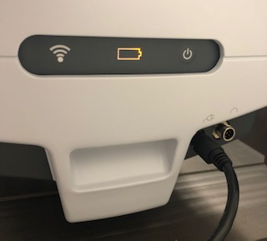

1. Carry the Delta4 computer back to Physics and plug back in the network and power cables.
2. Evaluate the beam statistics. See section “Analyzing Dose” in procedure “Delta4 for DQA.”
3. Print the Physics Report. See section “Printing a Report” in procedure “Delta4 for DQA.”
4. Upload the Physics Report to MOSAIQ. See procedure “Upload Physics Report to MOSAIQ.”